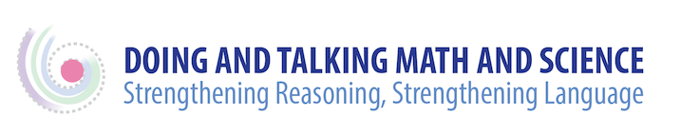

Supporting Students’ Self-Monitoring and Self-Management

You’ve set in motion a type of instruction that helps students strengthen their reasoning and their language effectiveness, but you’ve also activated meta-cognitive and meta-linguistic awareness in your students. To help them continue to develop, and to support their ongoing agency as learners, consider setting up weekly or bi-weekly reflection activities. Here are some reflection questions that may be helpful for individual students. You can find questions for small group reflection in a separate document (Monitoring Progress-Student Work Groups) on the Resource page of this website.

Student Reflection Questions: Individual Students
- What’s the most interesting idea I heard someone say this week?
- Am I being responsible about expressing my ideas?
  - If not, why am I hesitating? What can I do to change this? What help could I ask for?
- Am I understanding and following everyone’s ideas? What could I do to get better at this? What help could I offer if I’m having trouble understanding someone? What could I ask?

